Selecting the bucket

* Select the bucket and open the list of items

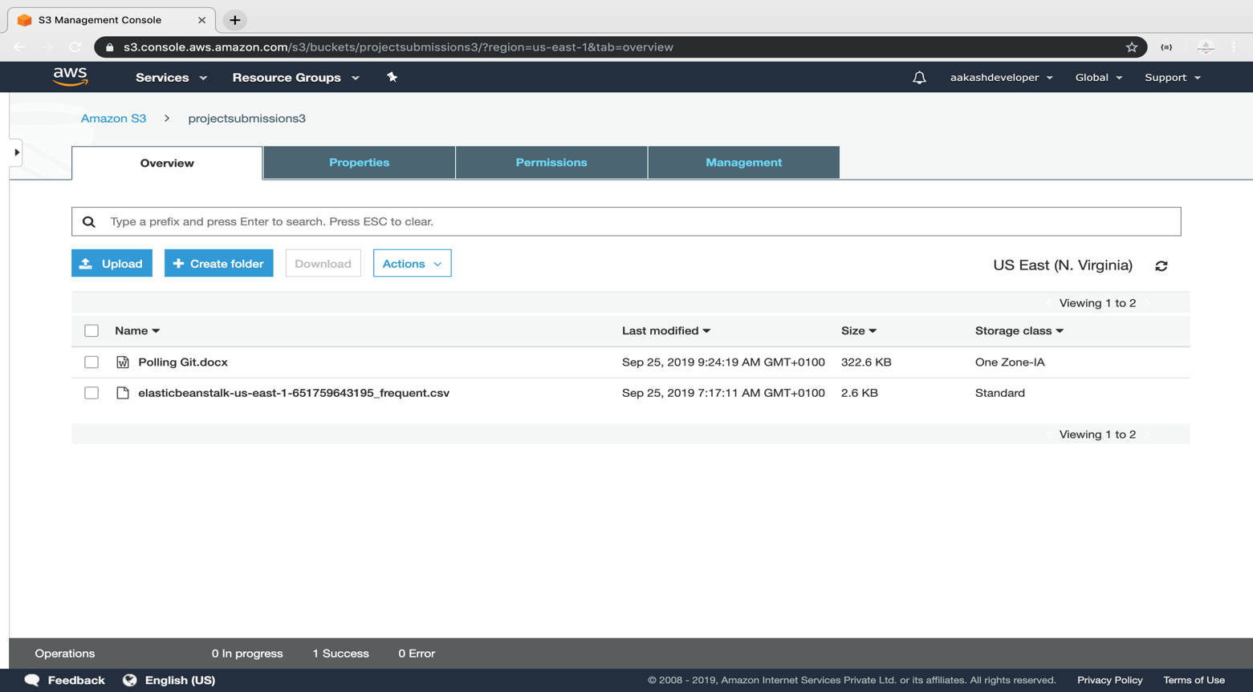

Setting the storage class of an object

* Click on *Upload* and select the file and click *Next*

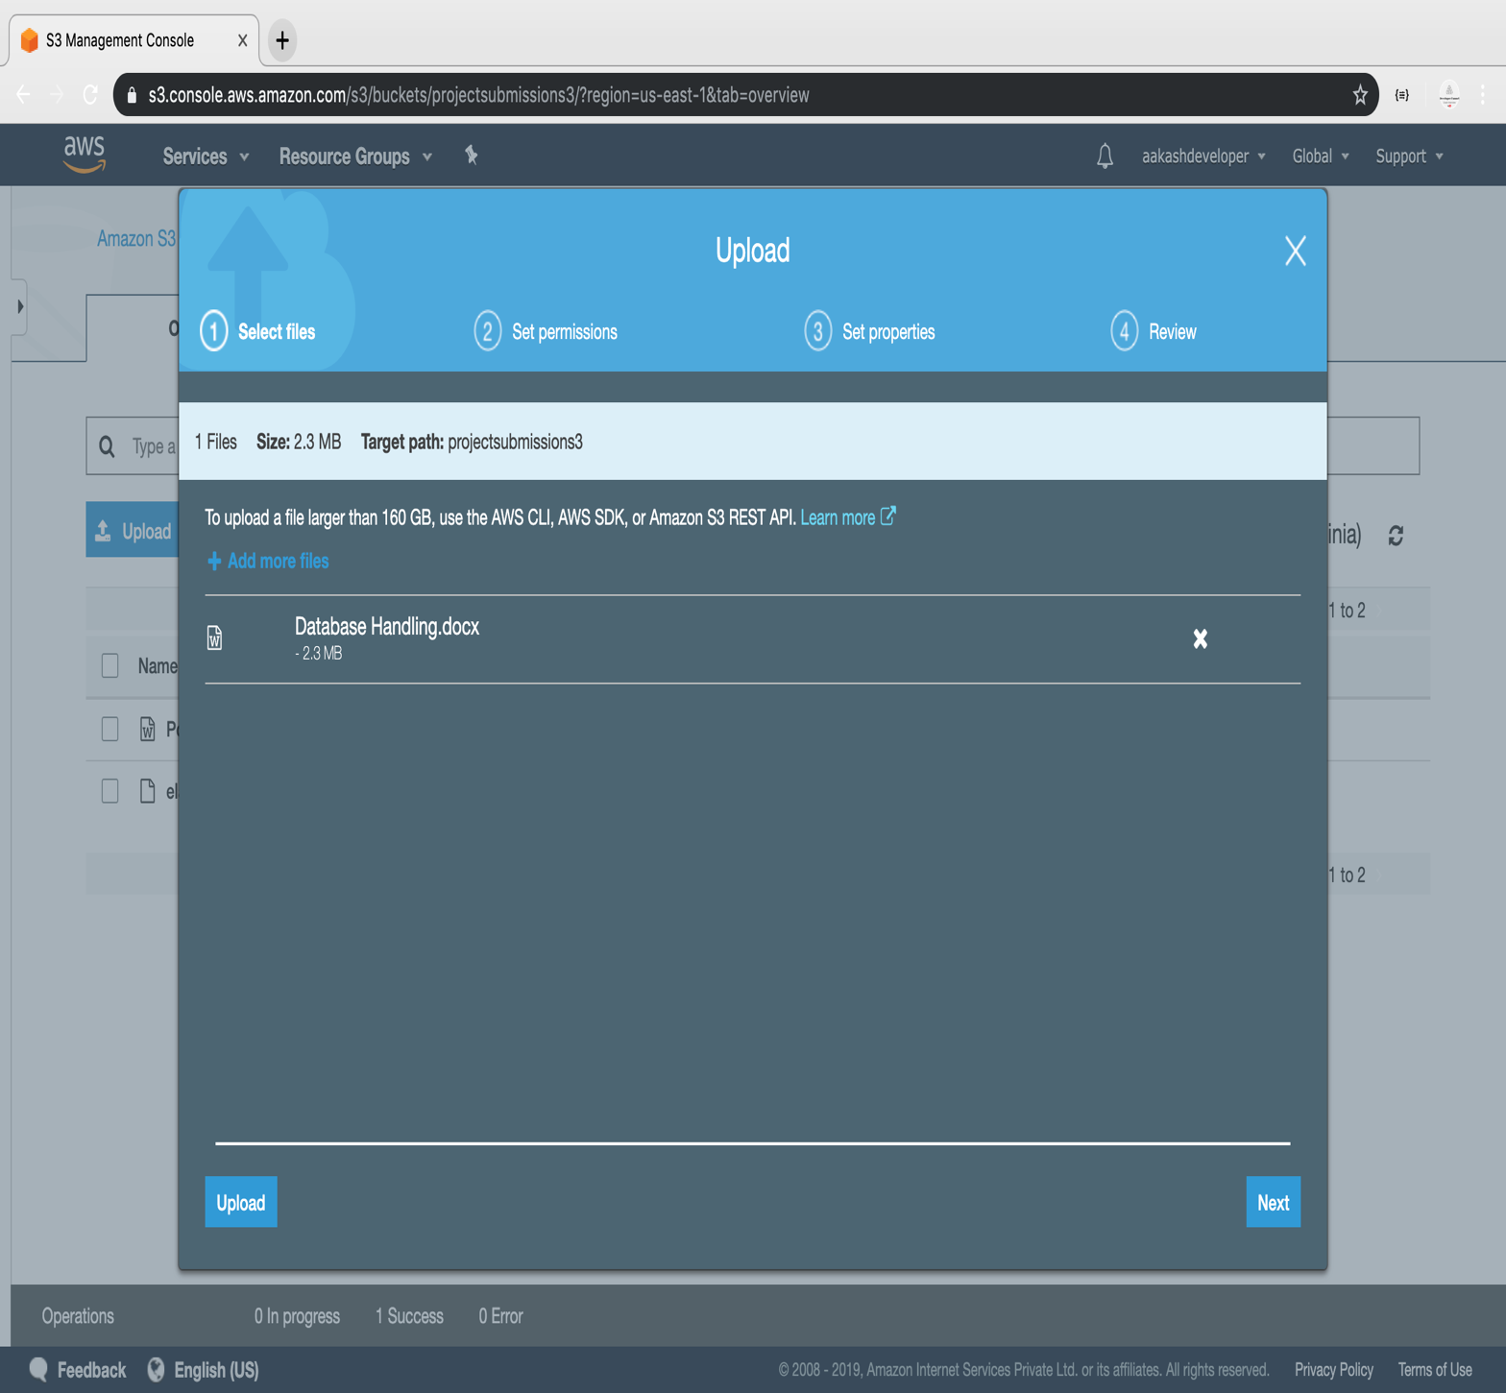

* Select the class and click *Next*

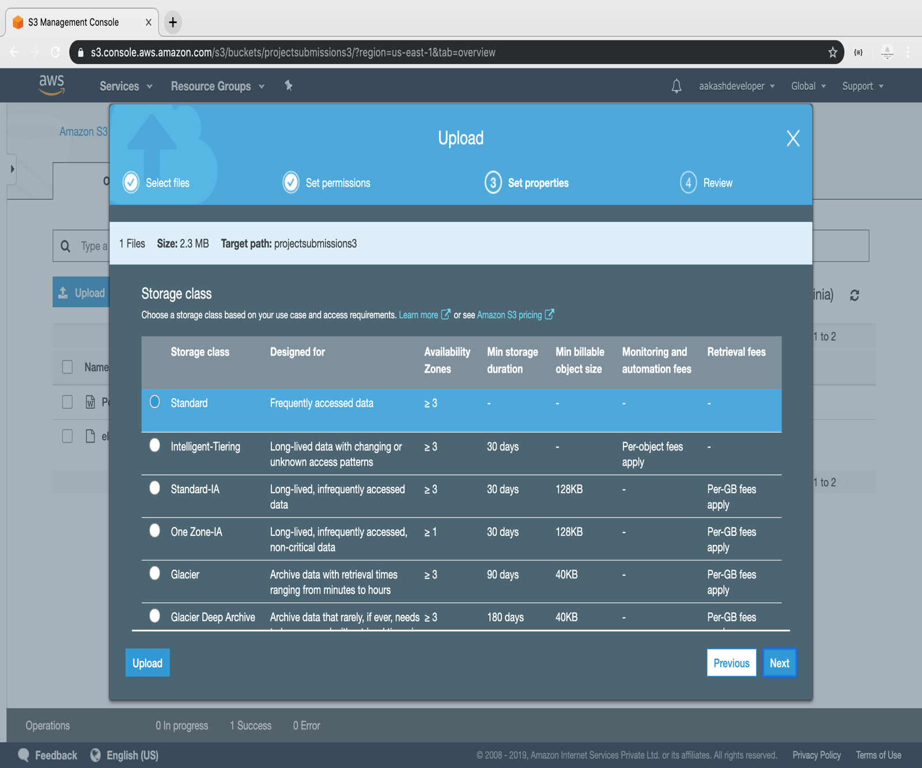

* The class will get assigned to the uploaded object

